**1.6 Ambiguity in Natural language/ Why NLP is Hard**

Natural language is extremely rich in form and structure, and very ambiguous in nature.

• Many input can mean the same thing and vice versa.

• Interaction among components of the input is not clear.

Therefore we face some of the difficulties that while designing algorithms for NLP. There is need to use various machine learning techniques in NLP.

**Ambiguity:** For same word, different interpretations or meanings are there.

Ambiguity is present at various levels like word, sentence, paragraph, context, pronoun.

**Different Types of Ambiguity**

**1) Lexical Ambiguity: Same word, different meaning.**

**For e.g. word “back” can be a noun ( backstage), an adjective (back door) or an adverb (back away).**

For e. g: The word silver can be used as a noun, an adjective, or a v

erb

**She bagged two silver medals. [Adjective]**

**Silver is bright. [Noun]**

**She made a silver speech. [Adjective]**

**His worries had silvered his hair. [Verb]**

Lexical ambiguity can be resolved by **Lexical category disambiguation i.e., parts-of-speech tagging.**

**To resolve this ambiguity, additional knowledge regarding words is used according to context.**

**Lexical Semantic Ambiguity:** When a single word is associated with multiple senses.

**e.g. Withdraw some money from the bank**

**Do not go near the bank of the river.**

Word bank has two entirely different meanings in the context of its use.

For e.g.

**The tank was full of water.**

**I saw a military tank.**

Lexical Semantic ambiguity resolved using word sense disambiguation (WSD) techniques, where WSD aims at automatically assigning the meaning of the word in the context in a computational manner.

**2) Syntactic Ambiguity: For same sentences, multiple interpretations**

**e.g. The man saw the boy with binoculars.**

Structural ambiguity is of two kinds:

**a) Scope Ambiguity**

**b) Attachment Ambiguity**

**a) Scope Ambiguity:** Scope ambiguity involves **operators and quantifiers**.

Consider the example:

Old men and women were taken to safe locations.

The scope of the adjective(old) operator is ambiguous.

that is old men and old women or old men and women

The scope of quantifiers is often not clear and creates ambiguity.

Every man loves a woman.

The interpretations can be, For every man there is a woman and also it can be there is one particular woman who is loved by every man.

**b) Attachment Ambiguity:** A sentence has attachment ambiguity if a constituent fits more than one position in a parse tree.

The man saw the girl with the telescope.

‘with’ is attached to the girl or the man.

**3) Semantic Ambiguity:** This occurs when the meaning of the words themselves can be misinterpreted. Even after the syntax and the meanings of the individual words have been resolved, there are two ways of reading the sentence.

Consider the example,

**Seema loves her mother and Sriya does too.**

The interpretations can be Sriya loves Seema’s mother or Sriya likes her own mother.

Semantic ambiguities born from the fact that generally a computer is not in a position to distinguishing what is logical from what is not.

The car hit the pole while it was moving.

The interpretations can be The car, while moving, hit the pole and The car hit the pole while the pole was moving.

**4) Pragmatic Ambiguity:** Pragmatic ambiguity refers to a situation where the context of a phrase gives it multiple interpretation.

Hardest task. The problem involves processing user intention, sentiment, belief world, modals etc.- all of which are highly complex tasks.

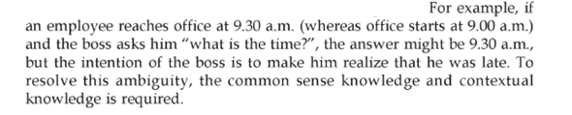

Pragmatic ambiguity arises when the statement is not specific, and the context does not provide the information needed to clarify the statement. Information is missing, and must be inferred.

**5) Discourse Ambiguity:**

Discourse is multiple coherent sentences.

The horse ran up the hill. It was very steep. It soon got tired.

Steep applies to surface hence ‘it’ can be hill. Tired applies to animate object hence ‘it’ can be horse.

**6) Referential Ambiguity:** The use of pronoun and other anaphora can cause referential ambiguity. The anaphora are replacement words that are used in place of noun in later part of discourse.

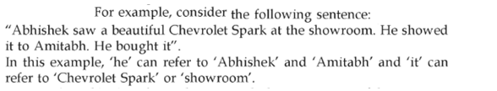

|  |
| --- |
| **Metonymy:** It deals with phrases in which the literal meaning is different from the figurative assertion. For instance, when we say “Samsung us screaming for new management”, we don’t really mean that the company is literally screaming |

